2018
Adult Curriculum Options

Referencing Bible curriculum
and thematic studies

Full collection www.commonword.ca/go/178

Bible studies www.commonword.ca/go/960

Thematic studies www.commonword.ca/go/841

The following links direct you to our adult curriculum materials on each topic.
By “Curriculum” we mean standard print or video curricula, trade books with chapter questions, and select online resources.

Please note that the online catalogue also provides links to more general resources on each topic.
(E.g., the “Caregiving” curriculum link is cross-referenced to a wider “Caregiving” selection online.)

Featuring:
Click on image for more information

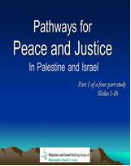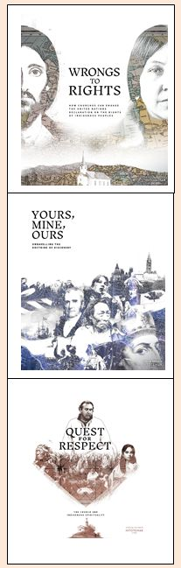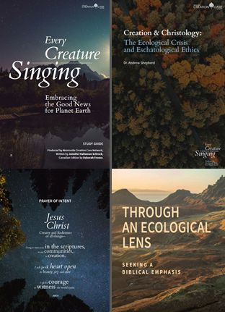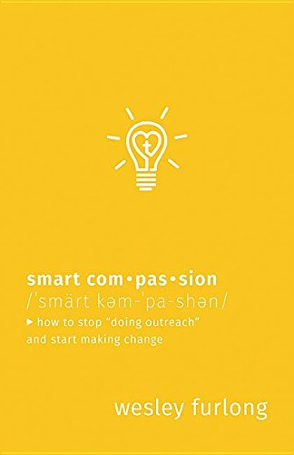

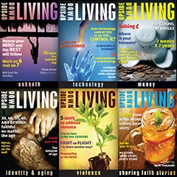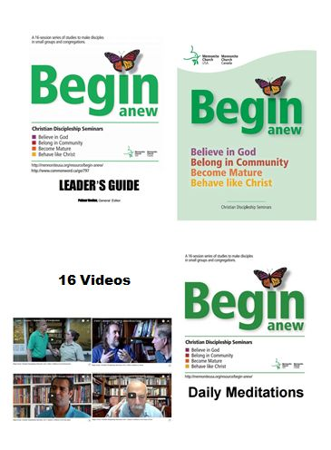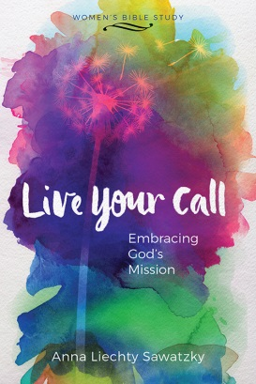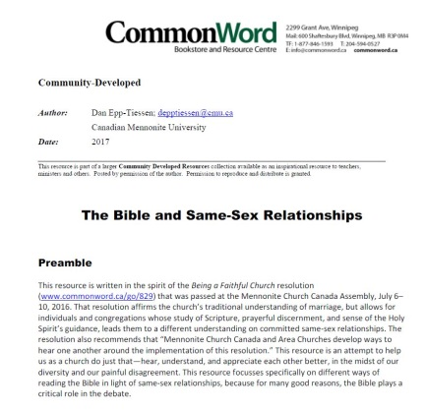

Anabaptists/Mennonites

Anabaptist/Mennonite Identity www.commonword.ca/go/846

Bible

Biblical Book studies www.commonword.ca/go/840

Biblical Drama www.commonword.ca/go/839

Biblical Hermeneutics www.commonword.ca/go/849

Jesus www.commonword.ca/go/895

Jesus’ Parables www.commonword.ca/go/850

Men in the Bible www.commonword.ca/go/906

New Testament www.commonword.ca/go/912

Old Testament www.commonword.ca/go/913

Overview of the Bible www.commonword.ca/go/914

Paul www.commonword.ca/go/916

Prophets www.commonword.ca/go/923

Sermon on the Mount www.commonword.ca/go/932

Women in the Bible www.commonword.ca/go/950

Biography

Biography (General) www.commonword.ca/go/852

Christian Saints www.commonword.ca/go/858

Christian Formation

Compassion www.commonword.ca/go/862

Creativity www.commonword.ca/go/865

Death and Dying www.commonword.ca/go/866

Discipleship www.commonword.ca/go/868

Forgiveness www.commonword.ca/go/876

Holiness www.commonword.ca/go/885

Interpersonal Relations www.commonword.ca/go/894

Joy www.commonword.ca/go/896

Love www.commonword.ca/go/901

Marriage Enrichment www.commonword.ca/go/902

Marriage Preparation www.commonword.ca/go/903

Parenting www.commonword.ca/go/915

Personal Discernment www.commonword.ca/go/918

Prayer www.commonword.ca/go/921

Sabbath www.commonword.ca/go/929

Self-Care www.commonword.ca/go/931

Sexuality www.commonword.ca/go/933

Spirituality (General) www.commonword.ca/go/935

Spirituality at Midlife www.commonword.ca/go/952

Spirituality of Children www.commonword.ca/go/936

Spirituality of Seniors www.commonword.ca/go/937

Spirituality of Young Adults www.commonword.ca/go/938

Spirituality of Youth www.commonword.ca/go/939

Stress/Fear www.commonword.ca/go/941

Transitions www.commonword.ca/go/945

Vocation/Calling www.commonword.ca/go/947

Church Year

Advent www.commonword.ca/go/752

Lent/Easter www.commonword.ca/go/483

The (wider) Church

Christian History/Identity www.commonword.ca/go/856

Ecumenism www.commonword.ca/go/871

Inter-faith Dialogue www.commonword.ca/go/893

Congregational Life/Leadership

Administration www.commonword.ca/go/844

Caregiving www.commonword.ca/go/854

Church Identity/Vision www.commonword.ca/go/859

Church Renewal www.commonword.ca/go/860

Congregational Discernment www.commonword.ca/go/863

Gift Discernment www.commonword.ca/go/879

Hospitality www.commonword.ca/go/887

Intentional Community www.commonword.ca/go/892

Leadership www.commonword.ca/go/899

Ministry with the Poor www.commonword.ca/go/908

Missional Church www.commonword.ca/go/909

Multicultural Ministry www.commonword.ca/go/911

Post-Modernity www.commonword.ca/go/920

Small Groups www.commonword.ca/go/934

Health

Health www.commonword.ca/go/883

Illness www.commonword.ca/go/889

Mental Health www.commonword.ca/go/905

Mission

Evangelism/Witness www.commonword.ca/go/873

Testimony www.commonword.ca/go/943

Peace

Conscientious Objection www.commonword.ca/go/864

Creation Care www.commonword.ca/go/615

Indigenous-Settler Relations www.commonword.ca/go/891

Peace (General) www.commonword.ca/go/917

Racism/Anti-Racism www.commonword.ca/go/924

Reconciliation www.commonword.ca/go/925

Religious Violence www.commonword.ca/go/927

Restorative Justice www.commonword.ca/go/928

Stewardship www.commonword.ca/go/940

Violence www.commonword.ca/go/946

War www.commonword.ca/go/948

Social Issues

Abuse www.commonword.ca/go/842

Addictions www.commonword.ca/go/843

Bioethics www.commonword.ca/go/851

Body www.commonword.ca/go/853

Disaster/Pandemic www.commonword.ca/go/867

Economics www.commonword.ca/go/870

Food Justice www.commonword.ca/go/875

Gender www.commonword.ca/go/878

Global Awareness www.commonword.ca/go/880

Human Trafficking www.commonword.ca/go/888

Immigration www.commonword.ca/go/890

Media www.commonword.ca/go/904

Mining www.commonword.ca/go/907

Physician-Assisted Dying www.commonword.ca/go/919

Prisons www.commonword.ca/go/922

Refugees www.commonword.ca/go/926

Suicide www.commonword.ca/go/944

Theology

Apocalypse www.commonword.ca/go/847

Atonement/Salvation www.commonword.ca/go/848

Christology www.commonword.ca/go/895

Doubt/Questions of Faith www.commonword.ca/go/869

Evil/Satan www.commonword.ca/go/874

Future www.commonword.ca/go/877

God (General) www.commonword.ca/go/881

Grace www.commonword.ca/go/882

Heaven/Hell www.commonword.ca/go/884

Hope www.commonword.ca/go/886

Language of Faith www.commonword.ca/go/898

Politics and Religion www.commonword.ca/go/816

Science and Religion www.commonword.ca/go/930

Suffering www.commonword.ca/go/942

Worship

Children and Worship www.commonword.ca/go/855

Communion www.commonword.ca/go/861

Worship (General) www.commonword.ca/go/949

